**Accreditatie overzicht**

**Training Course Owner**

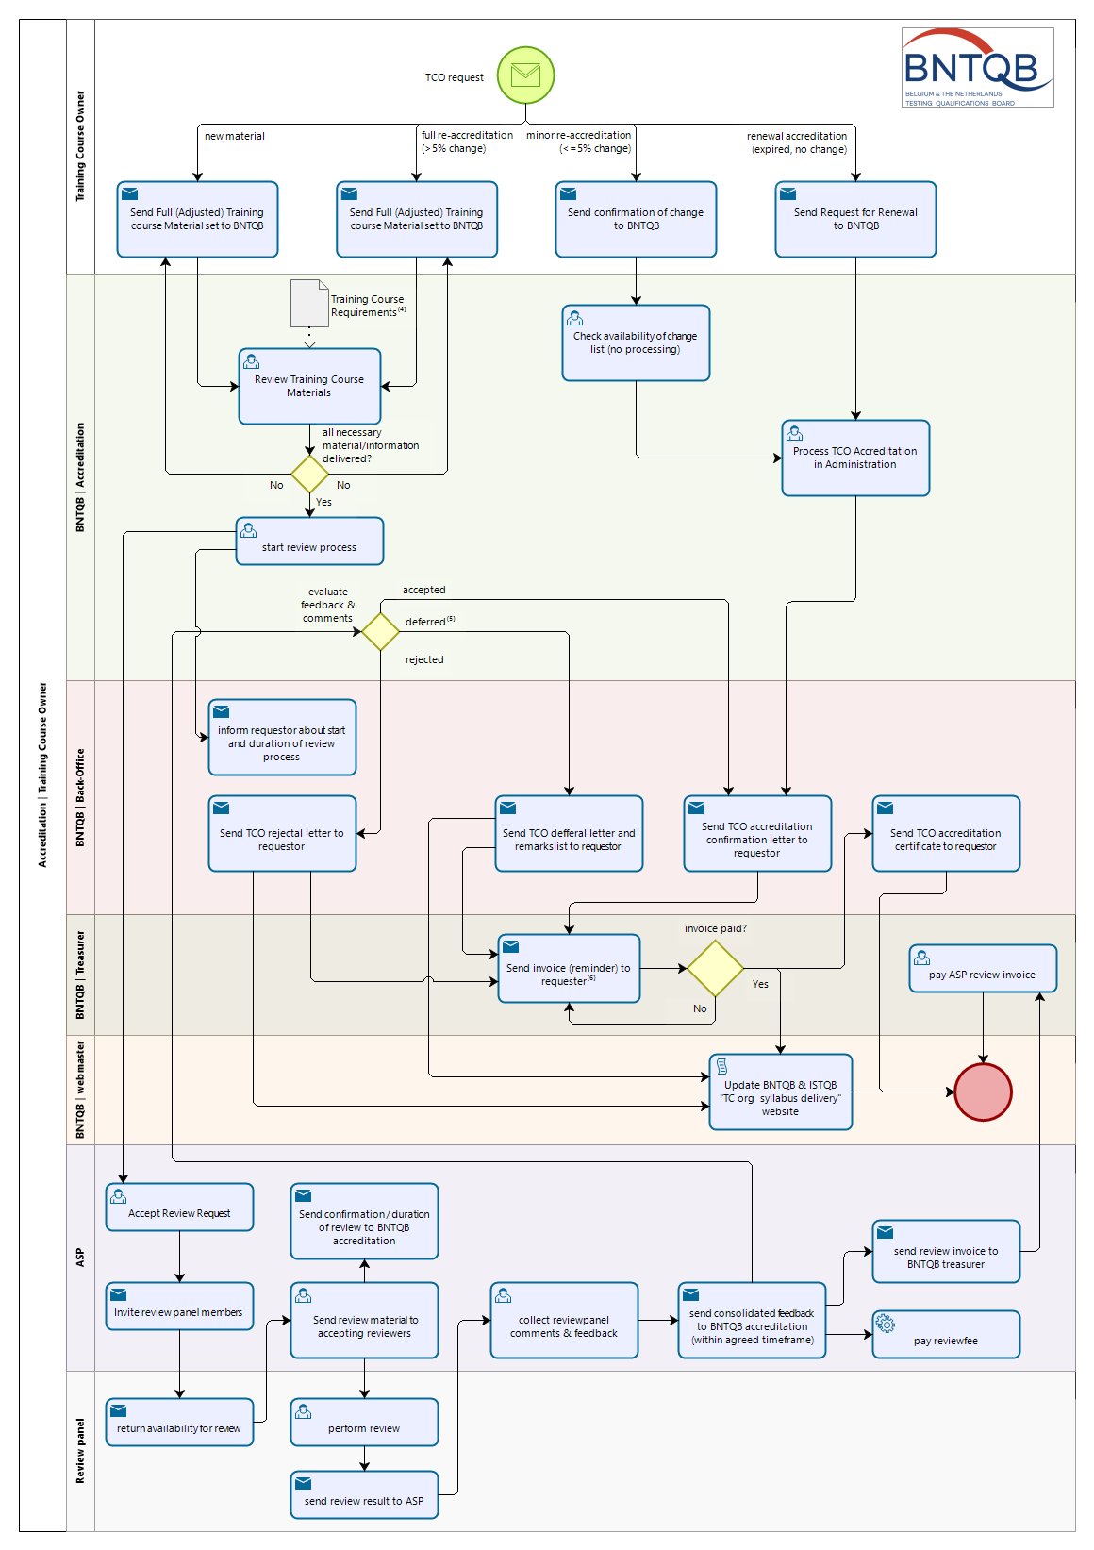

**Training Course Provider**

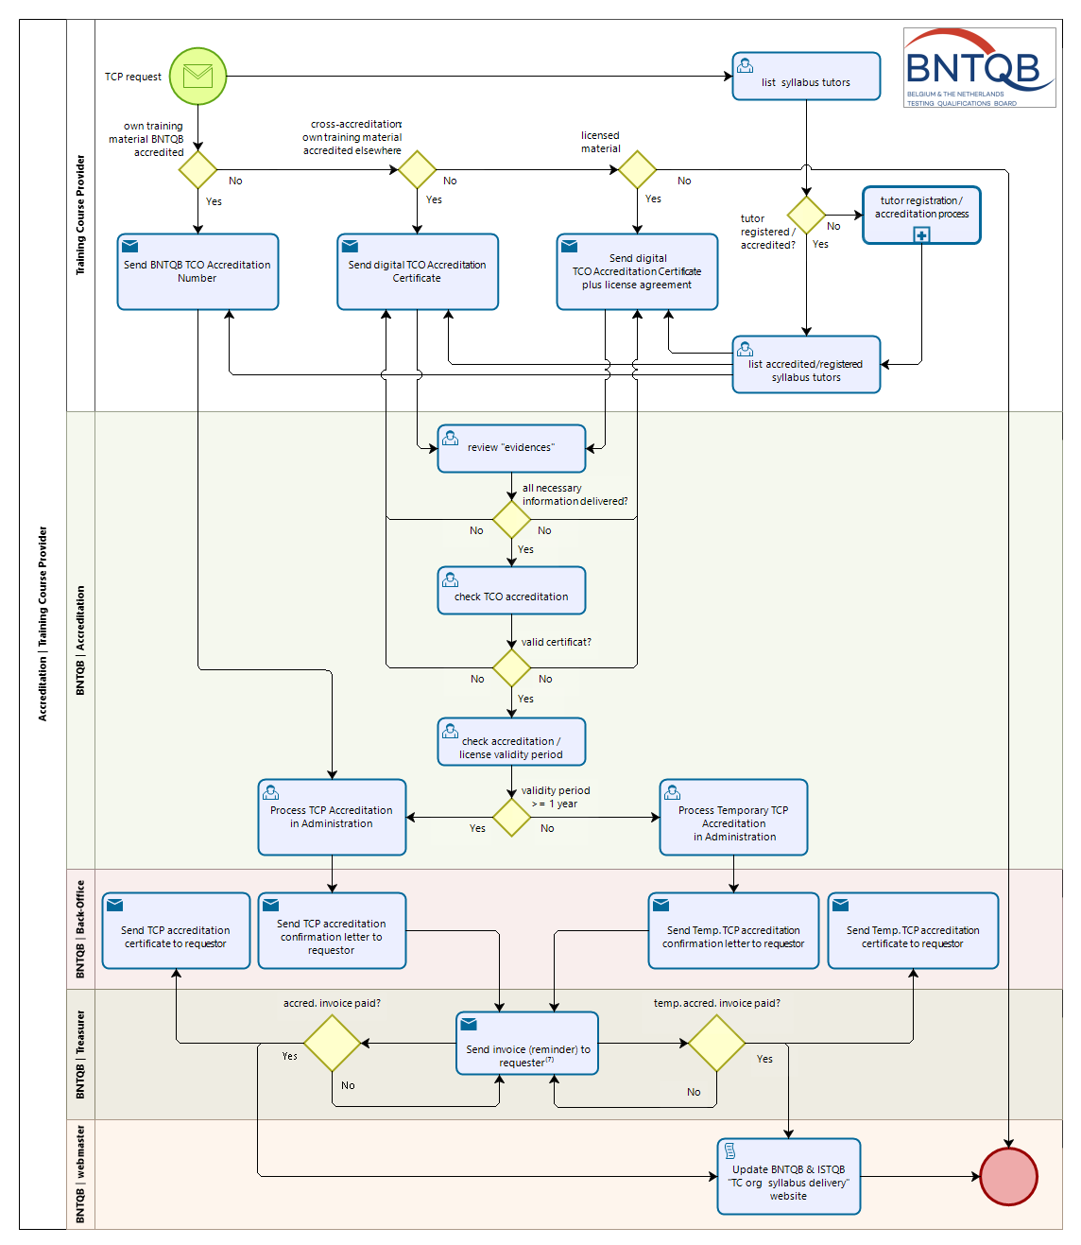

**Tutor Registratie/Accreditatie**

